DriveTime API

A Database for Professional Car Dealerships

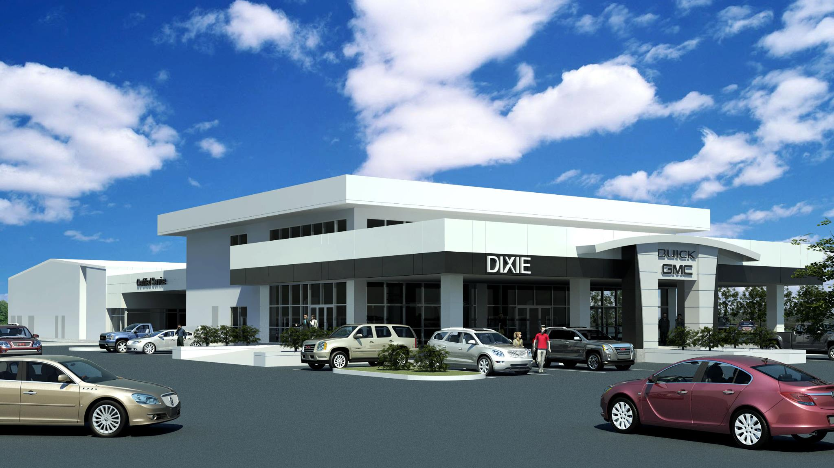

Amanuel Challa

TAble of  
Contents

Introduction of Drivetime api 1

Group b profile 1

Drivetime api process description 2

how the database works 2

user requirements 3

Entity relationship diagram 5

Assumptions 6

Task list 7

## Introduction of Drivetime api

The development of DriveTime API began in September of 2019 by four Towson University computer science students. Its purpose is to offer a flexible and detailed database for car dealerships on a local and national level. It keeps track of the different vehicles that the dealership has in inventory, customer information, and maintenance records. Since the system is just a backend API, it can be applied to any front-end user interface, depending on the needs specified by each car dealership. The database will make keeping vehicle sale records and inventory efficient for each dealership.

The team of Towson University students who worked on this project made it in TypeScript and Node.js. The database can be used and managed in the Postman API testing tool. The project was developed for the Database Management Systems class and incorporates the team’s knowledge of database and software the they acquired throughout the semester.

## Group b profile

Group B is a software engineering company founded in Baltimore, Maryland in 2019. They currently have one location, which is in Baltimore, Maryland but they have developed and oversee many software engineering project across the company. The company is known for being a gateway to the technology industry for recently graduated students. Once students get experience, they go off to big fortune 500 hundred companies like google, amazon and facebook.

## Drivetime api process description

## how the database works

When a customer makes an account, their information is stored for records and they receive a unique ID that will stick with them for the rest of their relationship with the company. Customers can browse the inventory and place orders through the database. Once a customer places an order, the availability status of the vehicle changes. Vehicles are categorized by trucks, luxury vehicles, suvs, coupes, and are further subcategorized by features (such as leather seats, sun roof, automatic transmission, etc.). Each vehicle has a unique ID.

When a customer places an order, they are required to specify payment and their insurance policies. The customer has to the option to request a loan, in which they will be directed to finance companies specified by the dealership. The status of the payment (whether its complete, the start date, end date and description) is kept and available for customers to view.

Administration are allowed to add and remove vehicles to and from the inventory, remove orders, and customer information. Employees are allowed to view vehicles in the inventory, keep track of maintenance request, mark vehicles as sold when a sale is made on location, view customer information, and submit logs for work done on vehicles.

Customers are allowed to request maintenance and specify what they need done. It is the employees responsibility to log the job and indicate whether it has been completed.

## user requirements

1. **Database Requirements**

Customers

1. create an account with all necessary information to perform a purchase
2. reserve a car
3. make a request for a buy order
4. make a request for maintenance
5. browse existing vehicles in the inventory
6. see vehicles that they have reserved and purchased

Administrator

1. add or remove vehicles that are available/unavailable
2. should be able to view customer information
3. login and be directed to the proper dashboard
4. view inventory and the sales made on a daily report log

Employee

1. view a list of all vehicles in the system
2. submit logs for maintenance done on a vehicle
3. keep records of maintenance request
4. mark vehicles as sold if a sale is made on location
5. view customer information
6. **Expected Database Queries**
7. Find vehicles based on model, make, type, color, or features
8. Find the list of vehicles that have been reserved
9. Find the list of vehicles that have not been purchased
10. Find the list of vehicles that have been purchased
11. Find the list of customers with an open loan
12. Find the list of customers with a close loan
13. Find the list of maintenance records by vehicle ID
14. Find the list of employees who have submitted maintenance logs for specific car
15. Find the customer who owns a specific vehicle

## Entity relationship diagram

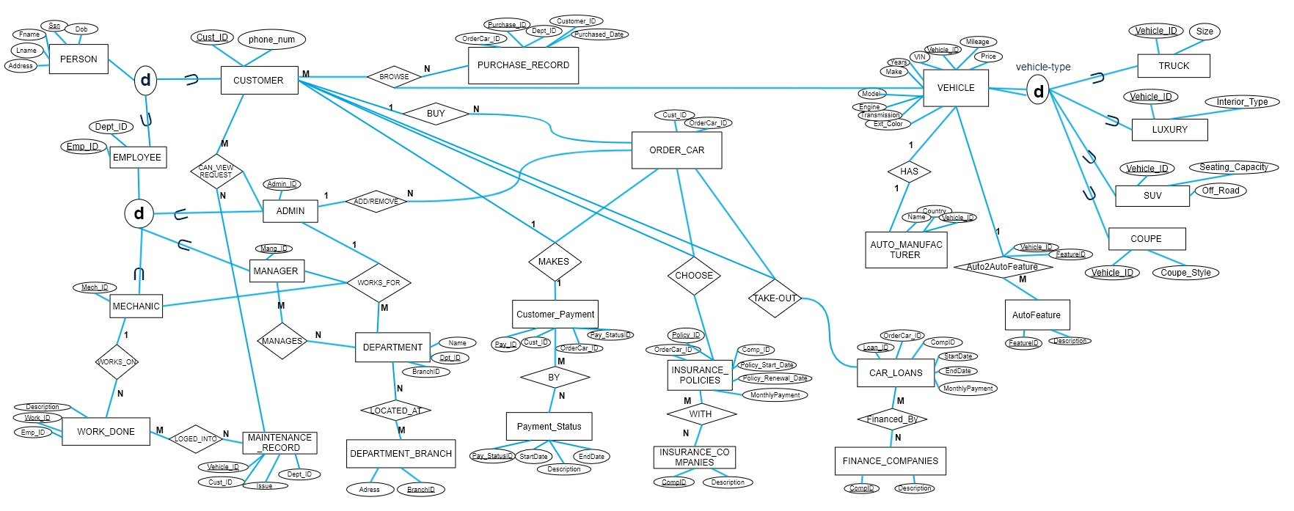

## Assumptions

* Each customer owns a car bought from the dealership
* Each vehicle is insured
* Admin has added vehicles to the inventory
* Each vehicle in the inventory is for sale

## Task list

|  |  |  |  |
| --- | --- | --- | --- |
| task | start date | end date | duration |
| Pick a topic | 26-Aug | 9-Sep | 15 |
| gather requirments | 9-Sep | 10-Sep | 1 |
| ERD draft | 16-Sep | 23-Sep | 7 |
| schema diagrams | 30-Sep | 21-Oct | 21 |
| coding | 21-Oct | 1-Nov | 11 |
| API construction | 2-Nov | 20-Nov | 18 |
| API finalization | 21-Nov | 2-Dec | 11 |